VFD Motor Controller

Mackenzie Miller

Andrew Nguyen

Aidan Rader

Ryan Regan

**Final System Report**

REVISION – 0

28 April 2025

Final System Report

for

VFD Motor Controller

Prepared by:

_____________________________

Author Date

Approved by:

_____________________________

Project Leader Date

_____________________________

John Lusher II, P.E. Date

_____________________________

T/A Date

**Change Record**

|  |  |  |  |  |
| --- | --- | --- | --- | --- |
| **Rev.** | **Date** | **Originator** | **Approvals** | **Description** |
| **0** | 04/28/2025 | VFD Motor Controller Team |  | Draft Release |

Table of Contents Error! Bookmark not defined.

List of Tables Error! Bookmark not defined.

No table of figures entries found. Error! Bookmark not defined.

List of Figures Error! Bookmark not defined.

No table of figures entries found. Error! Bookmark not defined.

1. System Introduction Error! Bookmark not defined.

1.1. Block Diagram **Error! Bookmark not defined.**

2. Integration Error! Bookmark not defined.

2.1. Auxiliary Power Integration **Error! Bookmark not defined.**

2.2. PWM Integration **Error! Bookmark not defined.**

2.3. Relay Integration **Error! Bookmark not defined.**

2.4. Diagnostic Feedback Integration **Error! Bookmark not defined.**

3. System Conclusion Error! Bookmark not defined.

Table of Contents

List of Figures

No table of figures entries found.

# System Introduction

Our team was tasked with developing a Variable Frequency Drive (VFD). Most of the traditional motor control methods are inefficient and can lead to unnecessary energy consumption and wear on equipment. The aim of a VFD is to solve this problem by more precisely adjusting motor speed with frequency and voltage control, which helps to extend equipment lifespan and optimize performance.

Some key engineering challenges in our project include designing an efficient power conversion system, generating accurate three-phase pulse-width modulation (PWM) signals, and ensuring smooth integration with industrial applications. This project will help our sponsor and any other users to lower operational costs, enhance process control, and promote more sustainable energy use.

## Block Diagram

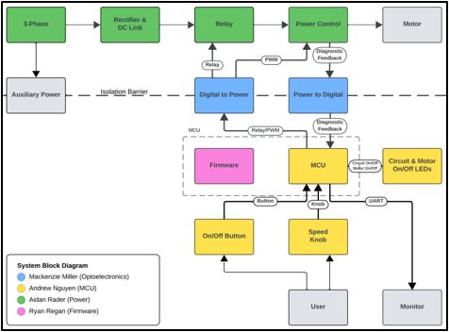

*Figure 1: VFD Motor Controller Block Diagram*

# Integration

## Auxiliary Power Integration

Auxiliary power integration includes taking 120VAC into the system from the wall, and transforming it to 15V, Iso15V, 3,3V, and Iso5V.The purpose of the Iso15V and Iso5V is to preserve the isolation barrier, where these two voltages have a different ground than the non-isolated voltages. Auxiliary power serves to create the voltages needed to power all of the components in the system. During integration of this part of the system, there were several challenges to overcome. The two main issues were component failure and testing errors. The 120VAC to 15V converter stopped working unknowingly sometime before the final demonstration. This component was not needed for testing at low voltage without the wall power, so when it came time to plug the system into the wall, this converter did not work. The converter was bypassed during the demo by applying 15V from a power supply to the output of the converter, and this showed that the auxiliary power worked for the rest of the system. Testing precautions were very important in testing the auxiliary power integration due to the high voltage coming from the wall. This made maintaining the isolation barrier and not mixing the grounds extremely important. During testing at one point, an oscilloscope probe was placed to measure the circuit which broke the isolation barrier. This broke the rectifier and exploded a trace out of the power electronics board. If the 120VAC to 15V converter had been replaced, the auxiliary power integration would have been a total success. Since this is a minor issue and was validated before breaking, auxiliary power was a success.

### 15 VDC to isolated 15 VDC Conversion

The 15 VDC to isolated 15 VDC converter takes 15 VDC and outputs 15 VDC. Parallel capacitors to the ground are used to filter and smooth the input and output voltages.

### 15 VDC to 3.3 VDC Conversion

The 15 VDC is sent to the 3.3 VDC buck converter and outputs 3.3 VDC. Parallel capacitors to the ground are used to filter and smooth the input and output voltages.

### 3.3 VDC to Isolated 5 VDC Conversion

The 3.3 VDC to isolated 5 VDC converter takes 3.3 VDC and outputs 5 VDC. Parallel capacitors to ground are used to filter and smooth the input and output voltages.

### 120 VAC to 15 VDC Conversion

The 120 VAC from the wall outlet is taken in by the 15V AC/DC converter and outputs 15 VDC. Parallel capacitors to the ground are used to filter and smooth the input and output voltages.

### System On/Off Button

An LED is connected to the MCU to indicate whether the system is on or off. The red through-hole LED will light up indicating the system is powered on and turn off when the system is not receiving power.

## PWM Integration

PWM Integration consists of six pulse width modules (PWMs) that were created in the firmware, Figure 2, and flashed onto the microcontroller (MCU) being output at 3.3V, 120 degrees apart and input to the optoelectronics (opto) board where they are transported to the power electronics across an isolation barrier and brought to 5V. These 5V PWMs are then input into the power control where they are transformed into modified sine waves that spin the motor.

This integration happened in multiple steps. The first step was firmware on the development (dev) board connected to the optoelectronics board. The purpose of this was to test the isolation and voltage increase of the optoelectronics board while the MCU board was still in progress. Once the output of the opto board was validated with the dev board, the MCU was added to the integration. The firmware was flashed onto the DSPICK33 using a PICkit 5. A PICkit 4 was originally used, but for some reason the code flashing was unsuccessful. Once the output PWMs of the MCU were validated, as seen in Figure 3, six PWMs, three phases high and low, at 3.4V, the opto board was connected. The input PWMs for isolation were the same PWMs being output of the MCU, and the output PWMs can be seen in Figure 4, the same PWMs as the input, just at 6.0V and 6.2V. After this was validated, the power control was connected, and the output was observed to be a modified sine wave as seen in Figure 5. The final step of PWM integration was the motor spinning. Once the professor confirmed the power control output was correct, the motor was connected, and when it was powered up at a very low voltage, it spun. This completed PWM integration.

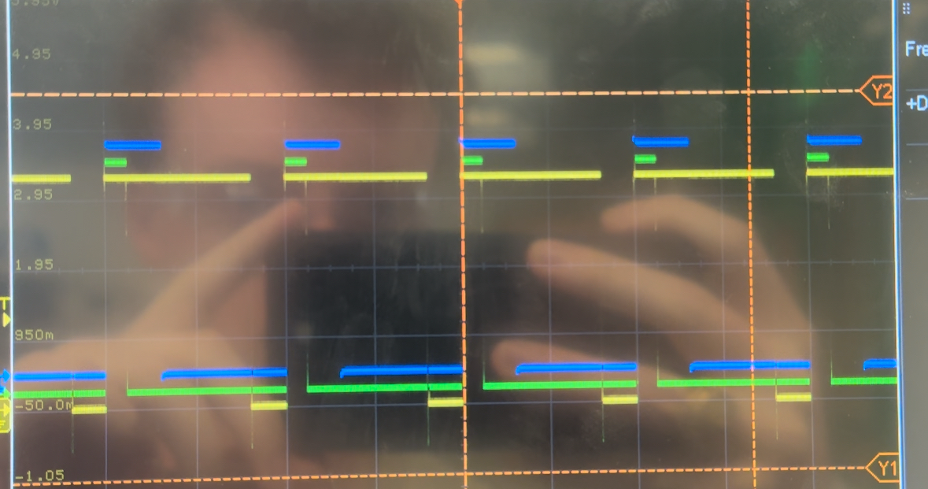  
*Figure 2: Oscilloscope output of PWMs created by Firmware*

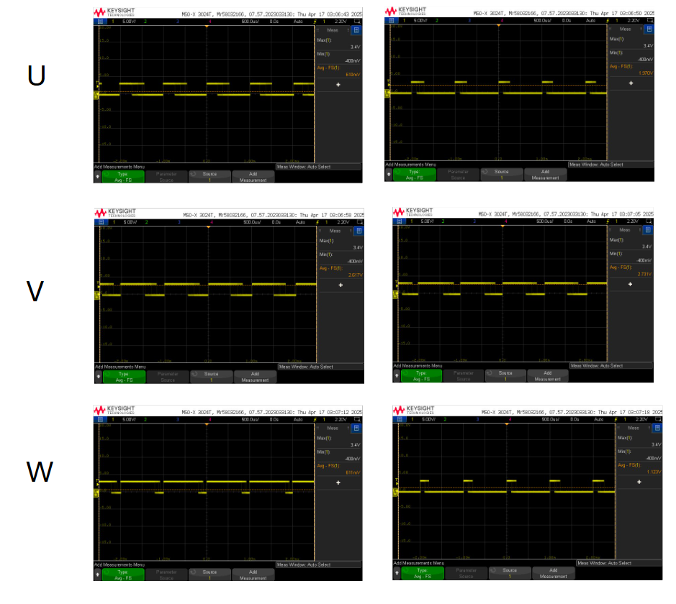

*Figure 3: MCU output & Isolation Input PWMs (3.4V)*

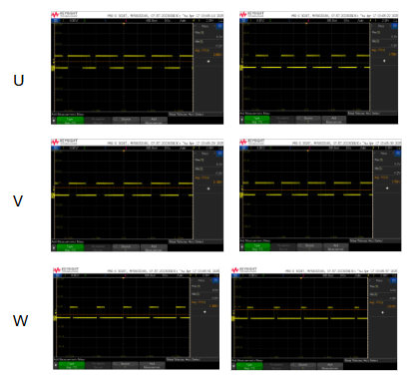

*Figure 4: Isolation output PWMs (6.0V-6.2V)*

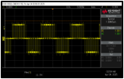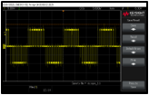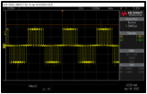

*Figure 5: Output of the power control for all three phases*

PWM integration was the most integral part of this system to get the motor to spin. There were many errors along the way that definitely slowed the process of getting the motor to spin, even at low voltage. A few notable hurdles were component failure, trace errors, and code errors. At one point, the optoelectronic board was working as expected, but due to a testing error, all of the isolators fried. This delayed the integration process because it took multiple days to get new parts in the mail and replace them. Additionally, on the power board, there was a trace error on the 0th revision causing a short of the power control, but was resolved on the next revision. Furthermore, the next revision had two more trace errors that were ultimately bypassed by over the board wires. One error was the bus voltage being used as the voltage measurement signal. Another error was the bootstrap capacitors being incorrectly in parallel with the high voltage outputs to the motor. Near the end of the project, the motor was spinning for a few days, then a new code was flashed to attempt our diagnostic feedback integration, and it ended up not working, so we reverted back to the old code backup.

### Speed Knob Functionality

One main requirement of the VFD motor controller is the ability to change the speed of the motor. In this system, a potentiometer, or speed knob, is how the speed controllability is implemented. When the potentiometer is spun, the frequency of the PWMs changes from 10Hz to 60Hz, linearly. In terms of integration, the knob was spun to adjust the speed at every step of integration and it worked pretty well. At the end of the project, the speed of the motor was the highest when the knob was in the middle, and it decreased as it was turned left or right. It is unknown why this happened, possibly an error in the code, but since this was a very minor error, it was not the team’s main focus. Overall, the speed knob did change the speed of the motor in a predictable way, so it was validated.

## Relay Integration

Relay integration in this system is realized by a button on the MCU, isolation via optoelectronics, and the relay on the power electronics board. When the button is pressed, a second LED turns on to indicate the motor is on and the relay signal gets set to 15V. This validates that the MCU is on and sending out a 3.3V signal that goes through isolation and to the power control. When the button is pressed again, the relay signal goes to 3.3V which cuts off power to the motor. This means the motor is off. During integration there were a few instances where the relay stopped clicking when the button pressed on, meaning that the relay was not working. This, however, was quickly fixed by replacing the MOSFET in that circuit that had broken.

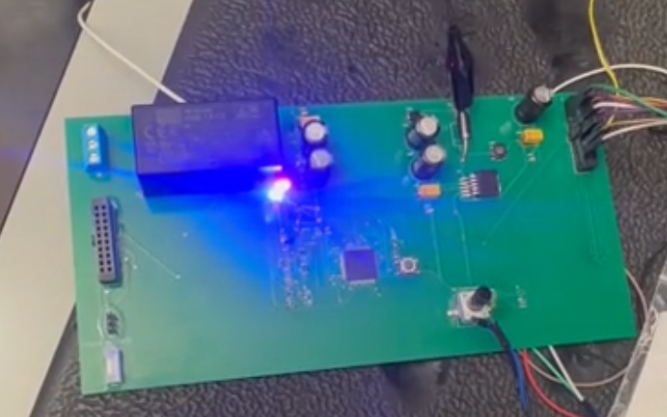

*Figure 15: Motor On LED (blue)*

## Diagnostic Feedback Integration

Diagnostic feedback in this system was designed as a way to check the voltage, current, and temperature of the system at all times. This includes the three signals sent out of the power control on the power electronics board. These signals, each at around 60V were then taken as input to the optoelectronics board where they were decreased and then transported across the isolation barrier to

Diagnostic feedback was not integral to making the motor spin, so it was essentially saved for last. Once the motor was spinning and all other integration was completed, diagnostic feedback came into focus. There were some issues, however. On the power control side, the current was too low to be sensed and communicated, and the temperature also did not work. The voltage signal, which represents the bus voltage, should have worked when plugged into the wall, at the full 120VAC, but for all testing besides final demo, the voltage was much lower, between 30V and 51V. Since this voltage was significantly lower than 120VAC, it is believed that the value was too low, so that feedback signal was not being communicated.

Additionally, there were problems with the microcontroller printing to the UART console. Upon linking the correct UART “transfer” and “receive” pins in the firmware, the USB-UART cable was still unable to transfer any print statements to the UART console.

In terms of validation, the optoelectronics board was tested at low voltage, with 15V input. The input to output ratio is 1V:0.26V, so if the full 60V had been applied, it is reasonable to assume that 15.6V would be output which is within the acceptable region.

# System Conclusion

The VFD Motor Controller project successfully met the goal of creating a system to control the speed of an AC motor by adjusting the input frequency and voltage. The motor spun successfully, and the speed knob and on/off button worked to control the motor. All four subsystems – including power, microcontroller, optoelectronics, and firmware – were successfully integrated and validated.

Though the potentiometer did not quite work as expected, it is most important that the motor worked and was controllable. The auxiliary power was officially finished during the final demonstration where it was successful in power the motor and components. The 120VAC to 15V converter failed during this test, but it was working previously, so it was assumed to just be a broken part. When this converter was bypassed, the motor spun as expected indicating the success of auxiliary power and PWM integration at full voltage, 120VAC. The motor also responded to the on/off button at low and high voltage, indicating success of relay integration. Diagnostic feedback was not quite successful mainly due to lack of time, but it was deemed an accessory feature to this project. Had there been a few more weeks, the problems could have been ironed out, and there would be feedback displayed on a UART console.